Mini Project # 2

Name: VEDANT KUMAR

ID: vxk180003

Name of group members: -

Contribution of each group member: -N/A-

--------------------------------------------------------------------------------------------------------------------------------------------------------------------

1 a.

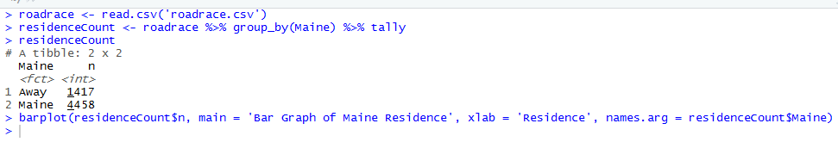

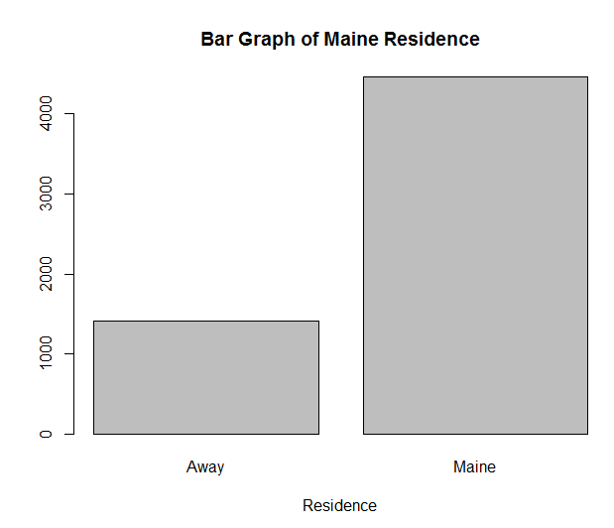

Most of the participants belong to the state of Maine. From the bar graph, we can say clearly that around 3 out of 4 persons belong to Maine.

b.

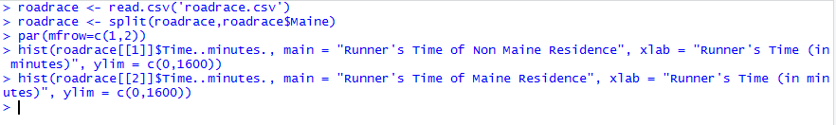

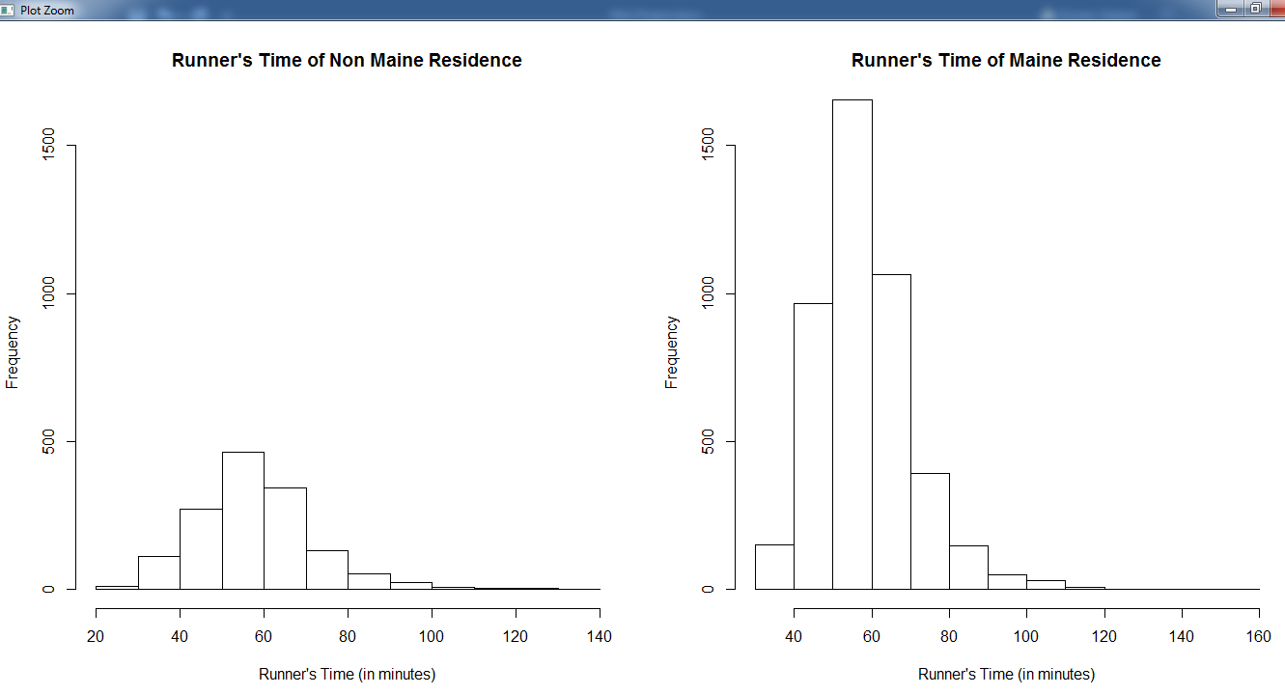

Following conclusions can be drawn:

* Both the graphs are right-skewed.
* Both the graphs have a median between 50-60 minutes. Hence, also mean will be marginally greater than median but lies between 50-60 mins.
* The fastest participant who finishes the race is from Non-Maine Residence while the slowest participant is from Maine residence.
* Non Maine residence have large variance hence, large SD.
* The range of Non-Maine residence Runner’s Time is between 20-130 minutes while Range of Maine residence is comparatively more 30-150 minutes due to an outlier present.

c.



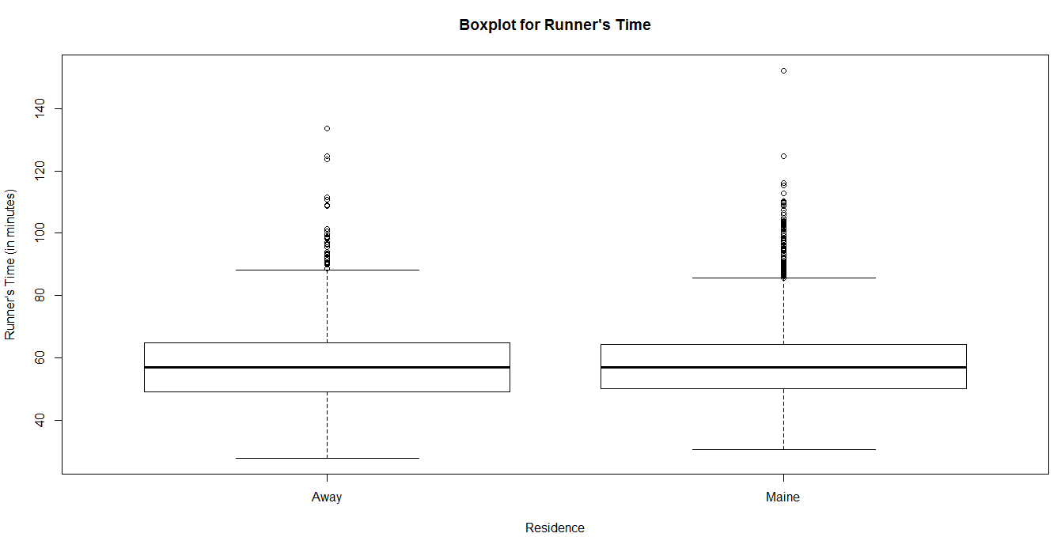

Inter Quartile Range for Non-Maine residence as well as Maine residence is roughly same but the outliers of Maine residence are more than Non-Maine. This states that Maine residence has an aggregated data centrally around Mean while Non-Maine residence has distributed data.

d.



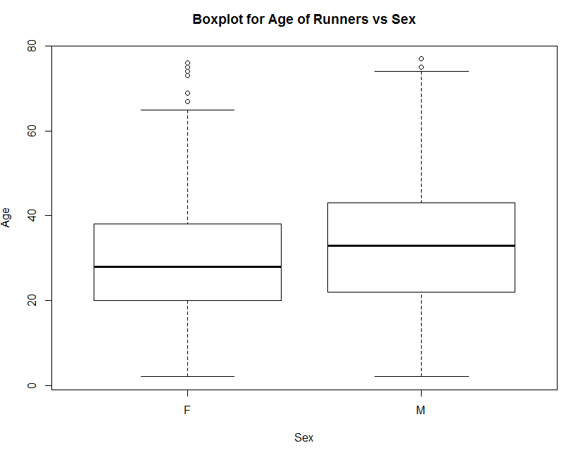

Following conclusions can be drawn:

* Median Age of Female participants is less than 30 while Median Age of Male participants is more than 30.
* Both types of Sex have same youngest and oldest age participant.
* The range is almost equal and around 5 to 80.
* Female participants have more outliers than Male participants. This gives that the data of Male participants are evenly distributed with exceptional 2 persons out of the curve.

2.



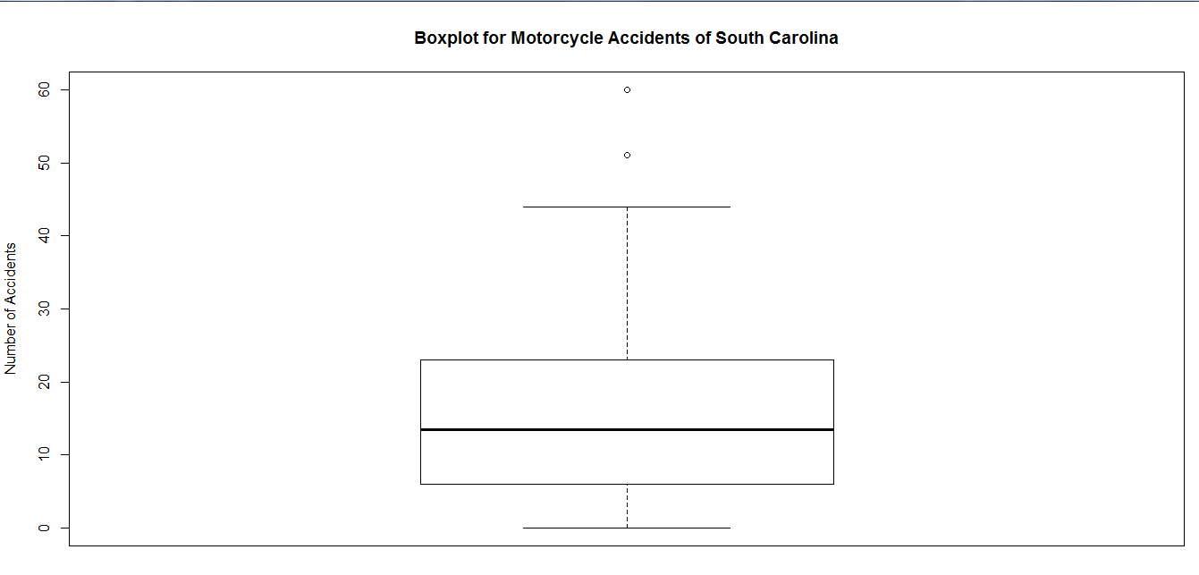

Following conclusions can be drawn:

* Median number of accidents in the counties of South Carolina is more than 10.
* Some counties perform exceptionally well with Zero accidents while 2 counties perform outstandingly bad having more than 50 accidents.
* The graph is right skewed distributed where the mean number of accidents will be more than the median.